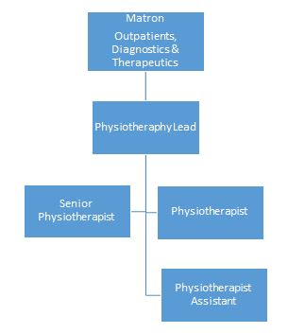

**Role Profile – Physiotherapist**

**Purpose:** To provide high standards of Physiotherapy and provide coaching and support to junior members of the team

**The post holder will**:

# Provide a high standard of physiotherapy care in the musculoskeletal outpatient service, including holistic and thorough,

# assessments, resulting in individualised, clinically reasoned and evidenced based treatment programs to patients, with close supervision from senior staff.

# Contribute and facilitate excellent standards of physiotherapy care to the orthopaedic Inpatients and be an active member of the multidisciplinary teams to

# support safe, effect treatment pathways and positive clinical outcomes.

# To support junior members of the team, including students and physiotherapy assistants with all aspects of their roles and learning needs.

# To actively support all of the departments’ services and objectives, including the delivery of in-service training, audits and participating in peer review.

**Measurement**

* Adhere to all regulatory standards and requirements, including the CQC, HCPC and the CSP
* Able to comply with the hospitals policies and procedures.
* Evidence own CPD and clinical competencies.
* Compliant with all mandatory and statutory training.
* Participation in the hospitals performance review process (PDR) evidencing the meeting of targets, objectives and behaviours.
* Familiarity and work within the organisations values

**Skills and Experience**

* BSc (Hons) Physiotherapy or equivalent
* 1 years experience at junior level within the MSK outpatient setting
* Basic awareness of respiratory principles and techniques, including ACBT.
* Aware of the KSF or equivalent
* Aware of the importance of clinical governance and its role
* Excellent communication skills, both written and verbal
* IT literate
* Excellent prioritisation, delegation and time keeping skills
* Able to work independently or as part of a team
* Able to demonstrate clinical and professional development
* Good initiative
* Strong patient centre approach
* Passionate
* Empathetic
* Adaptable and flexible
* Methodical and organised

**Key Result Areas**

* To assess, plan, treat, and manage outpatient MSK clients and complete all necessary documentation in a timely manner to the required standard.
* To provide high standards of care to the orthopaedic inpatients, providing rehabilitation and support to facilitate prompt discharge and successful recovery at home. This may be required at weekends .
* To review and progress post-operative orthopaedic patients in the outpatients setting
* To provide telephone advice to patients when appropriate
* To maintain own CPD and actively participate in IST
* To manage and progress own workload, with review and delegation to junior team members where appropriate
* Participate in the organisations staff appraisal process
* Maintain the safety of the working environment and equipment
* To participate in administrative duties when required to ensure the smooth running of the department

Be Caring
• We know what we do matters
• We’re proud and enjoy what we do
• We promote a culture of care, respect compassion and wellbeing
• We protect the mutual ethos
    Be Connected 
• We collaborate and share across teams, departments and the business
• We listen to understand each other and our member’s needs
• We support one another by having open and honest conversations
• We recognise that we’re stronger together
Be Brave
• We embrace change 
• We challenge and ask ‘why’ as well as  ‘why not’
• We always want to learn
• We are not afraid of trying new concepts and ideas
      Be Smart
• We approach problems with a solution mind-set
• We actively seek to improve and be better and we learn from our mistakes
• We spend members money wisely
• We’re invested in the future of our business


**Values**