**Purpose:** To provide administrative assistance that supports clinical activity and excellence in patient safety by providing a controlled

decontamination service for reusable medical devices in Benenden Hospital.

**The post holder will**:

* Work as part of the DS team and closely with the Decontamination Lead/Director of Infection Prevention and Control (DIPC).
* Contributing to the clinical care of the patient by achieving standards of excellence throughout all Decontamination Services

processes.

* Accurate recording, collation and auditing of information.
* Work with the team and internal customers to prioritise workload.
* Work in accordance with the department’s Standard Operating Procedures and Quality Management System.

**Role Profile – Decontamination Services Administrator**

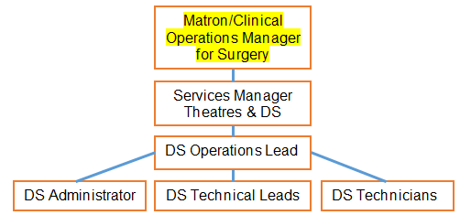

**Key Result Areas**

* To collate, update and maintain spread sheets and records including sensitive staff data .
* To organise and to produce agendas and minutes for DS, decontamination related and Infection Prevention and Control Meetings.
* To assist with administrative duties on the electronic tracking and traceability system.
* To plan and prioritise workload with consideration to the DS team and the needs of the internal customer and patients.
* To provide timely administrative support to the DS Operation Lead and Decontamination Lead/DIPC.
* Accurate and timely reporting of any decontamination service issues of significance or concern.
* To communicate and assist with enquires from internal customers, healthcare staff, auditors and decontamination consultants.
* To manage the dispatch, recording and receipt of repair instrument, liaising with repair companies.
* To contribute to and to support the department’s best practice and continuous improvement.
* To undertake duties consistent with the responsibility of the grade and needs of the service.

**Measurement**

To work in accordance with Departmental Policy, Standard Operating Procedures and Quality Management System.

Comply with the Hospital’s policies and procedures.

Adherence to and meeting the requirements of compliance and regulatory policies.

Achieve and maintain professional competence.

Performance to be measured against objectives and “Values – led” behaviours identified and agreed within the Personal Development Review.

**Skills and Experience**

Educated to A level/diploma level or equivalent experience.

Awareness or willingness to gain awareness of the decontamination processes, standards, legislation and guidance.

Excellent IT skills e.g. MS Office suite and PAS.

Experience in working in a customer centred environment.

Strong verbal and written communication skills ensuring tact and diplomacy whilst maintaining confidentiality.

Methodical and well organised with a high level of attention to detail.

Be flexible and adaptable to meet the changing needs of the workplace.

Demonstrate honesty, integrity and an even temper in the workplace.

Foster a culture of professionalism and a positive working team environment.

Be Caring
• We know what we do matters
• We’re proud and enjoy what we do
• We promote a culture of care, respect compassion and wellbeing
• We protect the mutual ethos
    Be Connected 
• We collaborate and share across teams, departments and the business
• We listen to understand each other and our member’s needs
• We support one another by having open and honest conversations
• We recognise that we’re stronger together
Be Brave
• We embrace change 
• We challenge and ask ‘why’ as well as  ‘why not’
• We always want to learn
• We are not afraid of trying new concepts and ideas
      Be Smart
• We approach problems with a solution mind-set
• We actively seek to improve and be better and we learn from our mistakes
• We spend members money wisely
• We’re invested in the future of our business


**Values**